Tutorial 9

Module Name: Black Box, White Box, Integration & System Testing
Test Case ID: TC09
Tester Name: Vora Riya

Scenarios:
- Scenario ID: BB01
Scenario
Verify login with valid credentials
Test Steps
1. Open OrangeHRM login page.
2. Enter valid username and password.
3. Click Login.

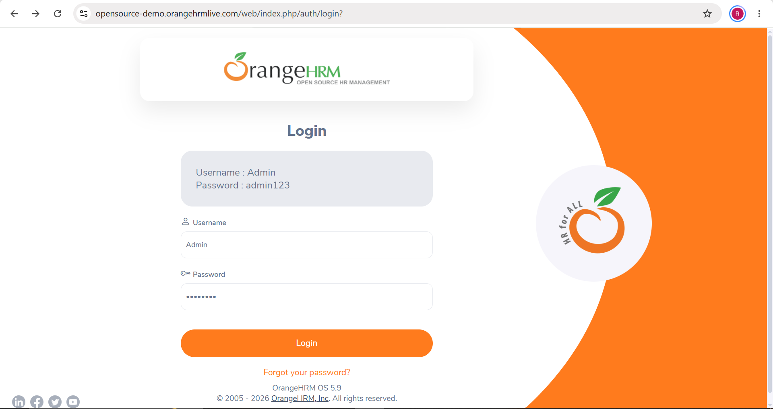

- Scenario ID: BB02
Scenario
Verify login with invalid credentials
Test Steps
1. Open login page.
2. Enter valid username and incorrect password.
3. Click Login.

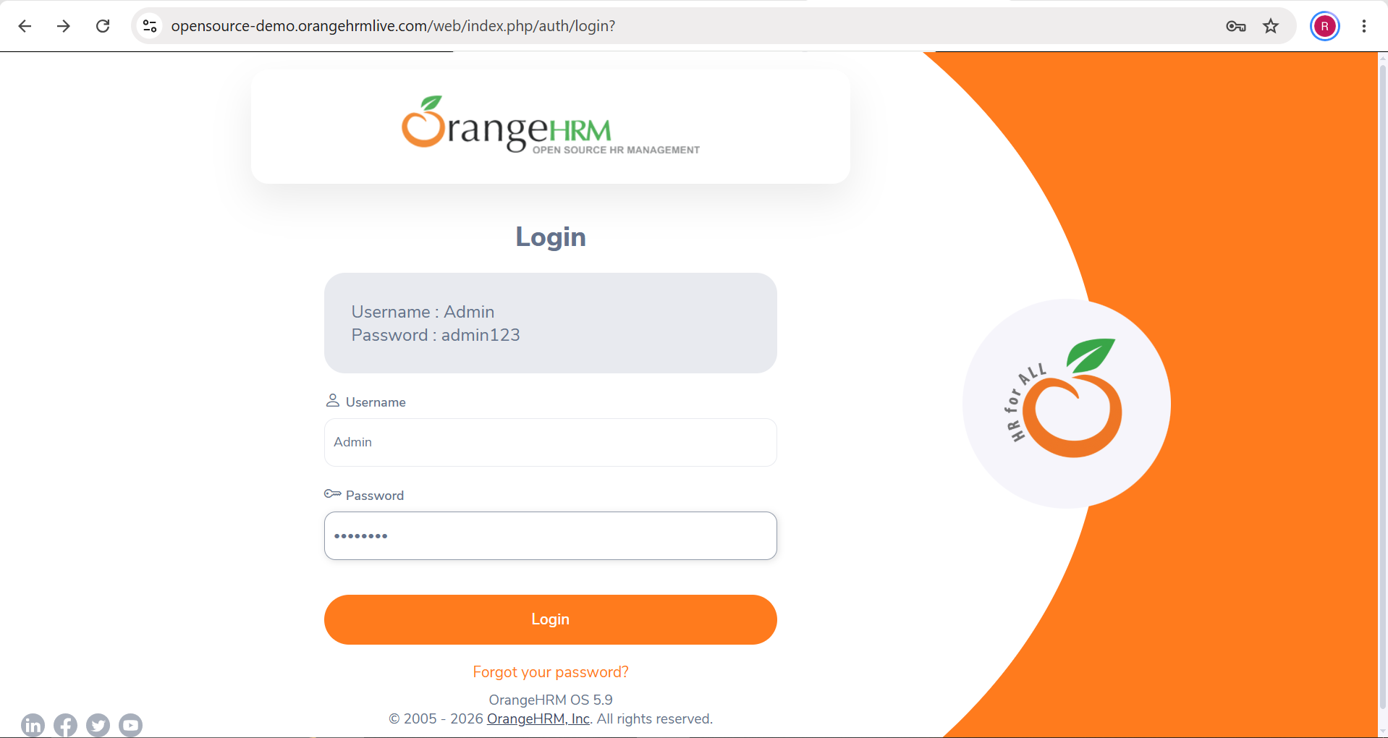

- Scenario ID: BB03
Scenario
Verify login with blank fields
Test Steps
1. Open login page.
2. Leave username and password blank.
3. Click Login.

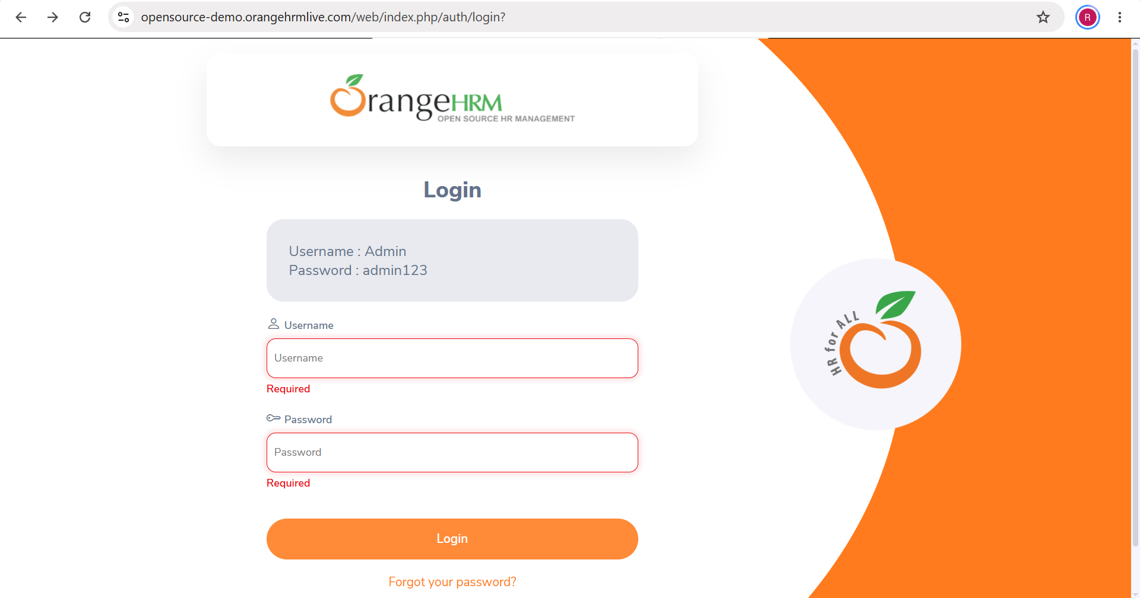

- Scenario ID: INT01
Scenario
Verify integration between login and dashboard
Test Steps
1. Enter valid credentials.
2. Click Login.
3. Verify that the dashboard opens and displays its main elements.

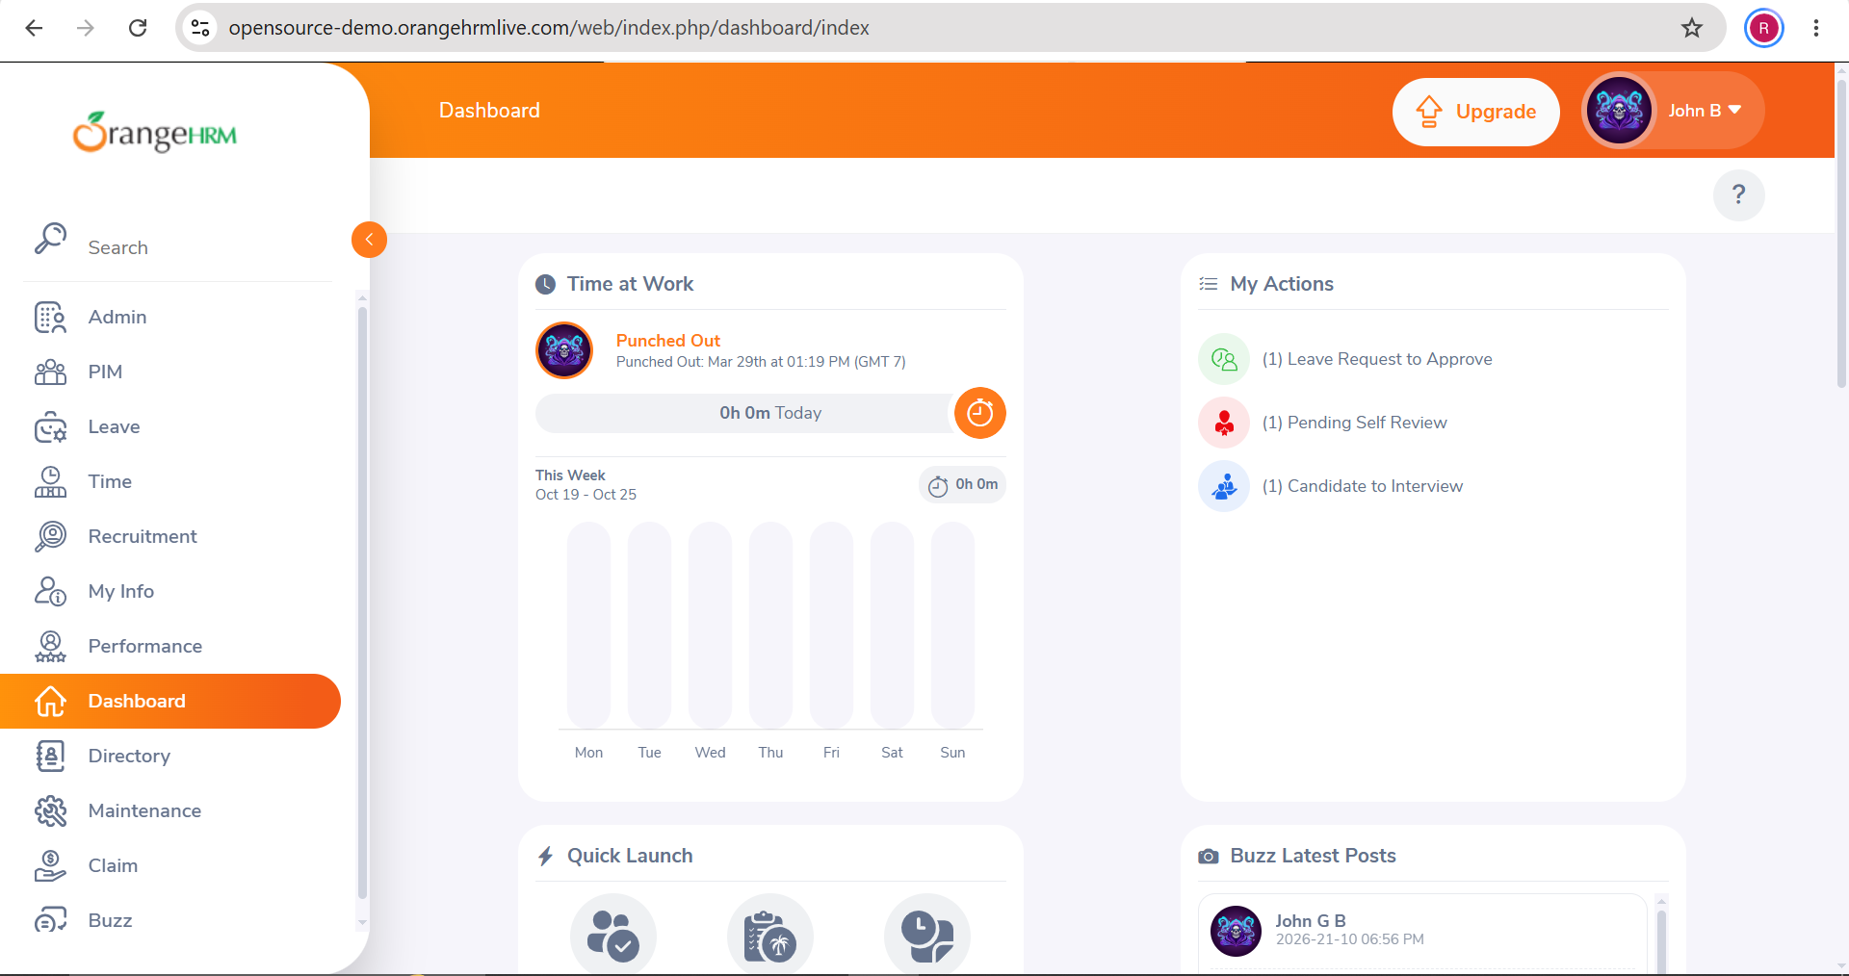

- Scenario ID: INT02
Scenario
Verify integration between dashboard and Employee Management
Test Steps
1. Log in.
2. Open the PIM/employee management section from the navigation menu.
3. Verify that the employee management page loads.
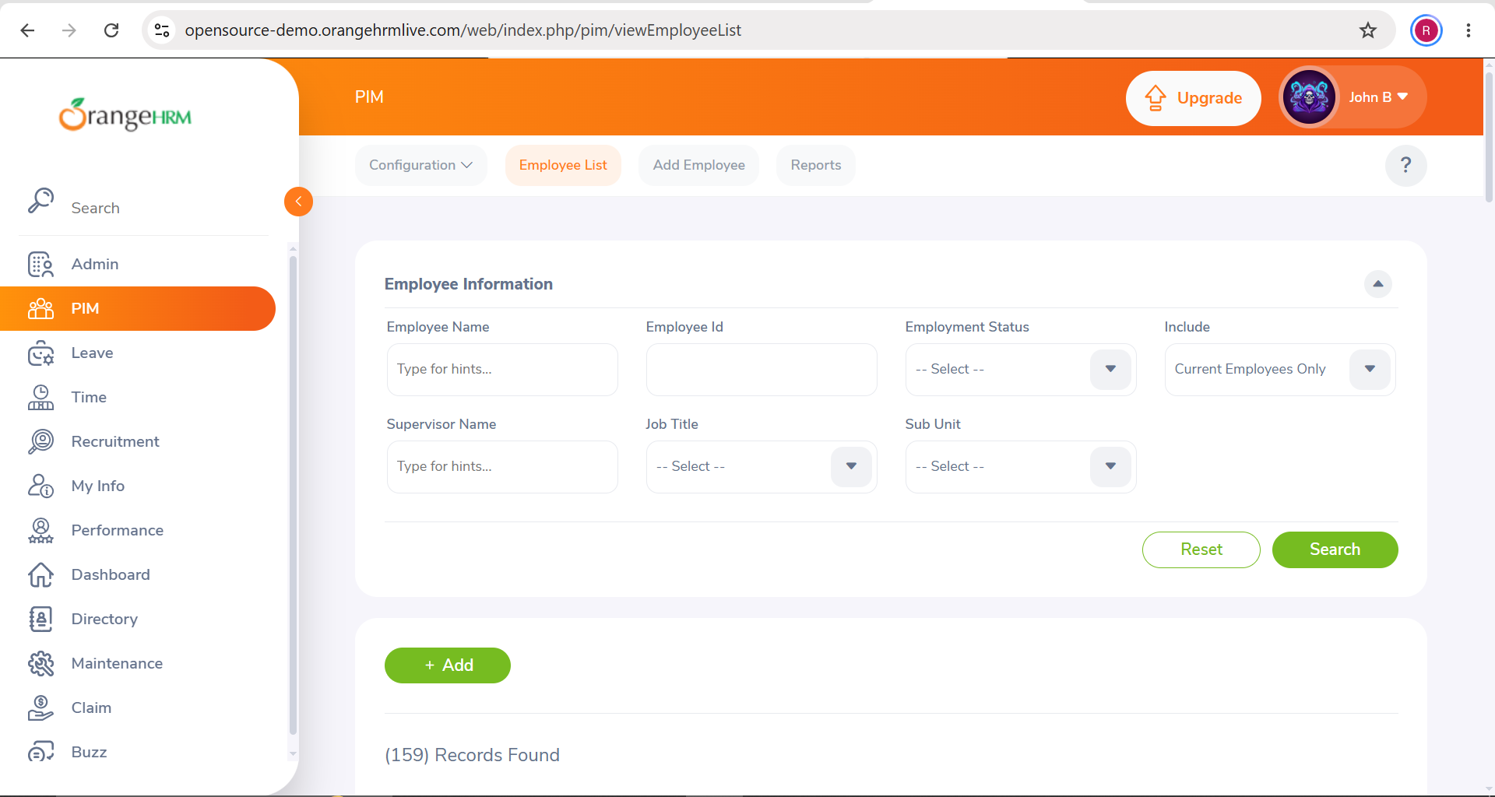

- Scenario ID: SYS01
Scenario
Verify the complete application workflow
Test Steps
1. Open OrangeHRM.
2. Log in.
3. Verify the dashboard.
4. Open PIM/employee management.
5. Verify that the page loads.

